CSA1702-ARTIFICIAL INTELLIGENCE

Program 1: Python Program to Solve 8-Puzzle Problem

Aim
To develop a Python program that solves the 8-Puzzle Problem using Breadth-First Search (BFS) to find the shortest sequence of moves from the initial state to the goal state.

Algorithm
- Represent the puzzle as a 3×3 matrix.
- Define the goal state.
- Locate the empty tile (0).
- Generate all possible moves: up, down, left and right.
- Use Breadth-First Search (BFS) to explore possible states.
- Keep track of visited states to avoid repeated exploration.
- If the goal state is reached, display the solution path.
- If all possibilities are exhausted, report that no solution exists.
Program
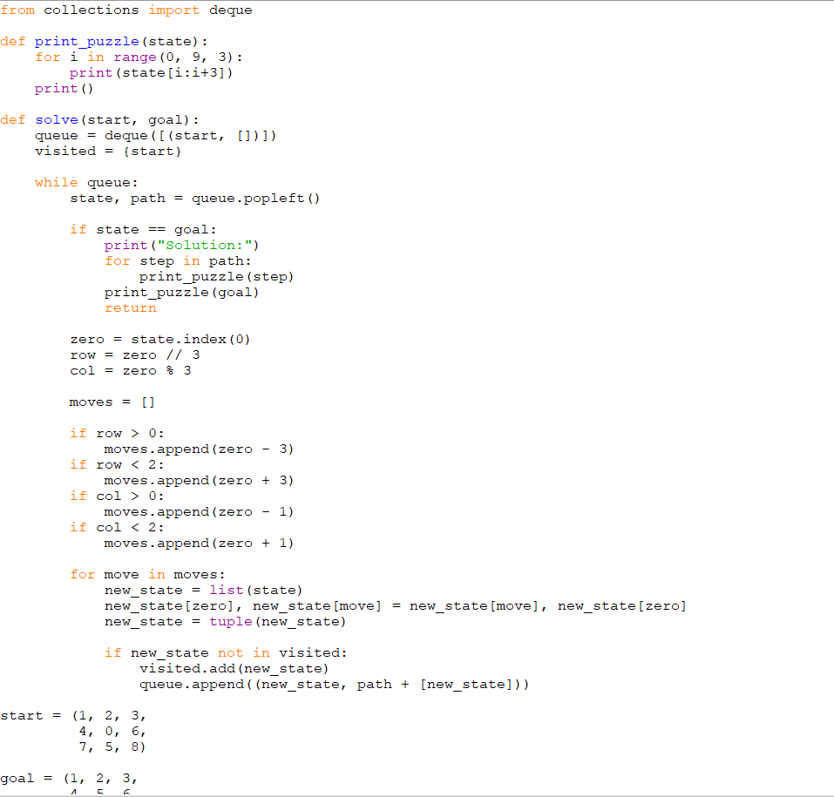
Output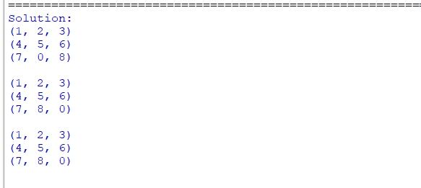

Result
Thus, the Water Jug Problem was solved successfully using Python and Breadth-First Search.
Program 2: Python Program to Solve 8-Queen Problem

Aim
To develop a Python program that solves the 8-Queen Problem using the Backtracking algorithm to place eight queens on an 8×8 chessboard such that no two queens attack each other.

Algorithm
- Represent the chessboard as an 8×8 matrix.
- Place one queen in each row.
- Check whether the position is safe.
- Make sure no two queens are in the same column.
- Make sure no two queens are on the same diagonal.
- If the position is safe, place the queen.
- If no safe position is available, backtrack to the previous row.
- Repeat the process until all eight queens are placed.
- Display the solution
Program
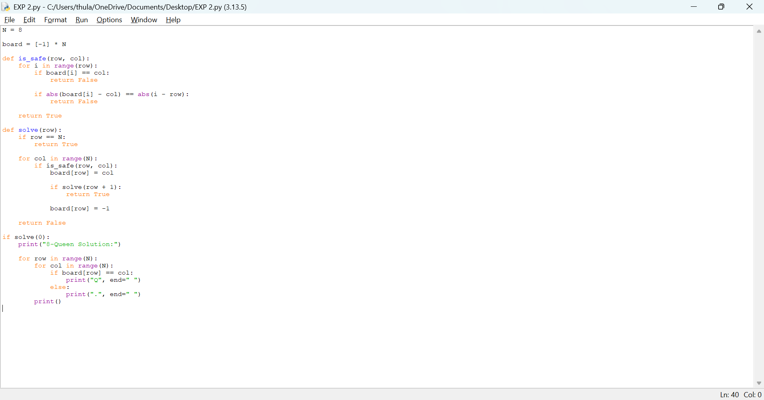
Output
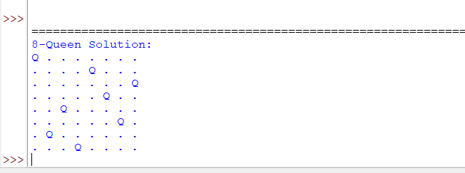

Result
Thus, the 8-Queen Problem was solved successfully using Python and the Backtracking algorithm.

Program 3: Python Program for Water Jug Problem

Aim
To develop a Python program to solve the Water Jug Problem using a search algorithm such as Breadth-First Search (BFS) to obtain the required amount of water.

Algorithm
- Define the capacities of the two water jugs.
- Define the target amount of water.
- Start with both jugs empty.
- Generate all possible operations: fill a jug, empty a jug, and transfer water from one jug to another.
- Use Breadth-First Search (BFS) to explore the possible states.
- Keep track of visited states to avoid repeated states.
- Check whether the target amount of water is reached.
- If the target is reached, display the solution.
- If all possible states are explored, report that the target cannot be reached
Program
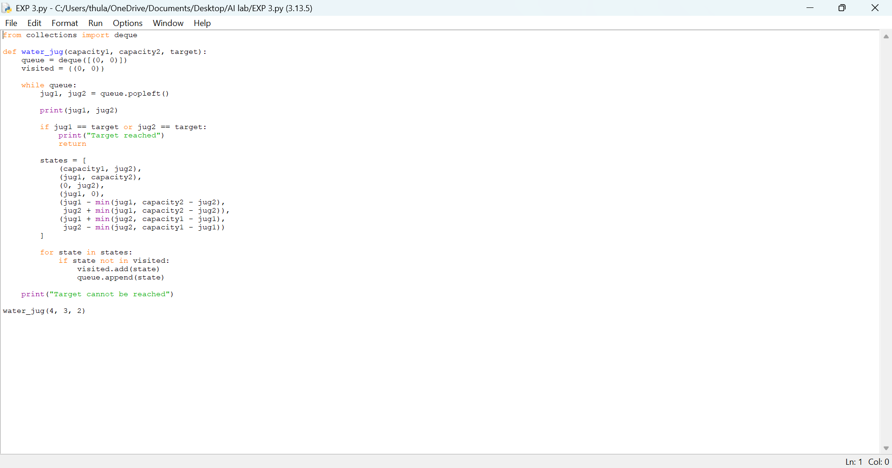

Output
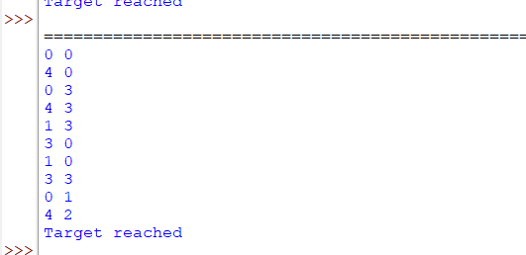

Result
Thus, the Water Jug Problem was solved successfully using Python and Breadth-First Search (BFS).

